project Management
and Scheduling
Event Ticketing with QR Check-in System
Project team
Student Name | Academic ID | Section
Mohamed Medhat Mohamed Ibrahim | 1202540904 | 2
Mohamed Ahmed Mohamed Abo-Shaheen | 1202540840 | 2
Mohamed Reda Mohamed Farag | 1202540862 | 2
Ibrahim Mohamed Mahmoud Khairy | 1202540507 | 1

Section 1: case study
The project will use Agile Prototyping. The system will be developed in small stages, with a working prototype shown early so that organizers and attendees can give feedback before the final version is completed.

Reasons for choosing this methodology:
- Early feedback: A prototype makes it easier to review the ticket-purchase process and the QR check-in screen.
- Lower technical risk: QR generation and ticket validation can be tested early.
- Flexible changes: New requirements, such as discount codes or different ticket types, can be added between iterations.

Section 2: Methodology (Agile Prototyping)

Background and Problem Statement
Event organizers may face long queues at entrances when tickets are sold or checked manually. Paper tickets and printed attendee lists can also make it difficult to identify duplicate tickets and keep attendance records accurate.

Proposed Solution
The Event Ticketing with QR Check-in System provides a digital way to publish events, sell tickets, and send a QR code to each attendee after a purchase is confirmed. At the venue, staff scan the QR code using a mobile device. The system checks the ticket against a central database and displays whether it is valid, already used, or invalid.

Main System Objectives
Objective | Description
Ticket purchasing | Allow attendees to browse events and purchase tickets online.
QR ticket generation | Generate a QR code for a confirmed ticket and send it to the attendee.
Entrance check-in | Let staff scan tickets and receive an immediate validation result.
Organizer dashboard | Show ticket sales, attendance, and capacity information.

Expected Benefits
The system is expected to reduce waiting time at entrances, make duplicate-ticket use easier to detect, and give organizers more accurate attendance information.

Section 3: Activity Schedule and Time Estimation
The project is divided into seven activities. Durations are estimated in weeks, and predecessor activities show which tasks must be completed before another task can start.
ID | Activity | Predecessor(s) | Duration
A | Requirements analysis and feasibility study | None | 2 weeks
B | System architecture and database design | A | 3 weeks
C | Core web application and backend API | B | 4 weeks
D | Mobile QR scanner development | B | 3 weeks
E | Payment gateway integration | C | 2 weeks
F | System integration and performance testing | C, D | 4 weeks
G | User acceptance testing and deployment | E, F | 2 weeks

PERT Time Estimation
PERT uses three time estimates for each activity: optimistic (a), most likely (m), and pessimistic (b). The expected duration is calculated using:
Expected duration (Te) = (a + 4m + b) / 6
ID | Optimistic (a) | Most likely (m) | Pessimistic (b) | Expected duration
A | 1 | 2 | 3 | 2 weeks
B | 2 | 3 | 4 | 3 weeks
C | 3 | 4 | 5 | 4 weeks
D | 2 | 3 | 4 | 3 weeks
E | 1 | 2 | 3 | 2 weeks
F | 3 | 4 | 5 | 4 weeks
G | 1 | 2 | 3 | 2 weeks

Section 4: PERT Chart / Network Diagram
The network diagram shows the order of the activities and where work can happen in parallel. After A and B are completed, activities C and D can proceed in parallel. Activity F waits for both C and D, while G waits for both E and F.

PERT Network Diagram
Start | → | A  2 weeks | → | B  3 weeks | → | C  4 weeks | → | E  2 weeks | → | G  2 weeks
 |  |  |  |  | ↘ |  |  |  | ↗
 |  |  |  |  | D  3 weeks | → | F  4 weeks | →
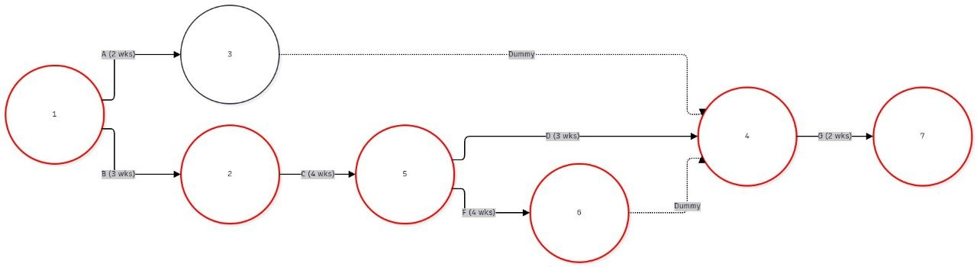

Network Analysis
Point | Explanation
Start | The project starts with activity A.
Parallel work | After B, both the web application (C) and mobile scanner (D) can be developed.
Merge at F | F starts only after both C and D are complete.
Final merge at G | G starts after both E and F are complete.

Critical path: A → B → C → F → G. Total duration = 2 + 3 + 4 + 4 + 2 = 15 weeks.

Section 5: Gantt Chart and Critical Path Analysis
The Gantt chart below places each activity on the project timeline. Activities on the critical path are highlighted in green. The schedule starts at Week 1 and finishes at the end of Week 15.
Activity | Description | W1 | W2 | W3 | W4 | W5 | W6 | W7 | W8 | W9 | W10 | W11 | W12 | W13 | W14 | W15
A | Requirements & feasibility | ■ | ■
B | Architecture & database |  |  | ■ | ■ | ■
C | Web app & backend API | s |  |  |  |  | ■ | ■ | ■ | ■
D | Mobile QR scanner |  |  |  |  |  | ■ | ■ | ■
E | Payment integration |  |  |  |  |  |  |  |  |  | ■ | ■
F | Integration & testing |  |  |  |  |  |  |  |  |  | ■ | ■ | ■ | ■
G | UAT & deployment |  |  |  |  |  |  |  |  |  |  |  |  |  | ■ | ■
Green bars indicate activities on the critical path; blue bars indicate other activities.

Critical Path and Slack Analysis
ID | Duration | ES | EF | LS | LF | Slack | Critical?
A | 2 | 0 | 2 | 0 | 2 | 0 | Yes
B | 3 | 2 | 5 | 2 | 5 | 0 | Yes
C | 4 | 5 | 9 | 5 | 9 | 0 | Yes
D | 3 | 5 | 8 | 6 | 9 | 1 | No
E | 2 | 9 | 11 | 11 | 13 | 2 | No
F | 4 | 9 | 13 | 9 | 13 | 0 | Yes
G | 2 | 13 | 15 | 13 | 15 | 0 | Yes

ES = Early Start, EF = Early Finish, LS = Late Start, LF = Late Finish. Slack is the amount of time an activity can be delayed without delaying the project finish.
Minimum project duration: 15 weeks. Activities A, B, C, F, and G have zero slack. Activity D has 1 week of slack, and activity E has 2 weeks.

